**2025**

******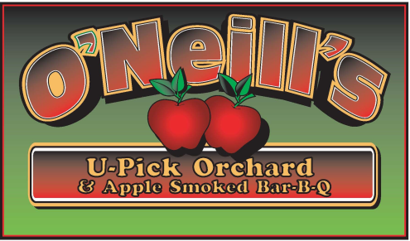**

**\*\*\*\*\*\***

**Last year for**

**our mailing**

Open Mon – Sun 10am to 6pm

(315) 677-9407

Compliments of the season!

Not our largest crop due to rain during bloom. However, it’s an ample crop save the N. Spy.

We are planning on opening **sometime** during the week of August 25th ,or the following week depending on the ripening of our earliest varieties Paula Red and zester.  **STAY TUNED**.

We are **planning** to open the apple wood smoked BBQ this September on weekends only. Please check Facebook for the latest updates.

**FACEBOOK OR Call to verify opening, availability and ripening**

Kitchen is open Saturdays and Sundays as well as on Labor Day and Columbus Day for: **APPLE FRITTERS, APPLE CIDER DONUTS, BBQ, CIDER HOUSE FREEZE, HOT DOGS, CIDERS, WATER AND SODA.**

**Please remember to check for availability.**

|  |  |  |
| --- | --- | --- |
| **U-Pick** | **Apples** | **Estimated Ripening Date** |
| **Raspberries \*** | **Zestar, Paula Red** | **August 25th ????** |
| **Raspberries \*** | **Ginger Gold, Jonamac** | **Early September** |
| **Raspberries \*** | **McIntosh, Pink Luster** | **Early to mid September** |
| **Raspberries \*** | **Gala, Crimson Crisp** | **Mid September** |
| **Raspberries \*** | **Honeycrisp** | **Early -Mid September** |
| **Raspberries \*** | **Cortland, Macoun, Greening** | **Mid to late September** |
| **Raspberries \*** | **Firecracker, Empire, Jonagold, Cordera** | **Early October** |
| **?** | **Golden Delicious, Red Delicious, N. Spy** | **Early to mid October** |
| **???** | **Crispin, Ida Red** | **Late October** |
| **???????** | **U-Pick?**  **Apples in stand** | **October 31 st we will be**  **Closing till next August** |

Keith F. O’Neill

4872 Route 20, Lafayette, New York 13084 (Just 4 min West from 81 Exit 15)

(315) 677-9407

**20 APPLE VARIETIES*FALL RED RASPBERRIES *BREADS* FRITTERS*CIDER*PIES*PUMPKINS*CHEESE*BBQ**







***APPLE SMOKED BBQ***

*Check on availability*

[**www.oneillsorchard**](http://www.oneillsorchard)

**Last year for mailer!!**

**Next year it will be on facebook and website**