2021
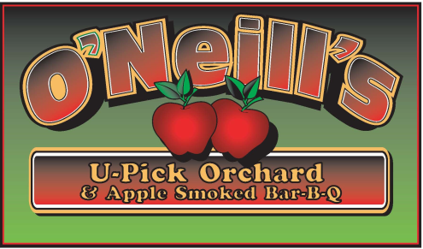

Open Mon – Sun 10am to 6pm
(315) 677-9407
Compliments of the season!

We hope all are well!
We are planning on opening Saturday the 28th.

This year’s crop looks good. There are a few varieties that are on the light side (Empire & N Spy) ? due to frost and/or their biennial nature

NEW VARITIES: PINK LUSTER-CORDERA-FIRECRACKER See below for estimated dates.

BBQ; Opening of BBQ this year is questionable due to labor shortage

Call to verify opening, availability and ripening

Kitchen is open Saturdays and Sundays as well as on Labor Day and Columbus Day for: APPLE FRITTERS, APPLE CIDER DONUTS, CIDER HOUSE FREEZE, HOT DOGS, CIDERS, WATER AND SODA.

Please remember to check for availability.

U-Pick | Apples | Estimated Ripening Date
Raspberries * | Zestar, Paula Red | August 28th
Raspberries * | Ginger Gold, Jonamac | Early September
Raspberries * | Pink Luster McIntosh | Early to mid September
Raspberries * | Gala, Crimson Crisp | Mid September
Raspberries * | Honeycrisp | Mid September
Raspberries * | Cortland, McCoun, Greening | Mid to late September
Raspberries * | Cordera Firecracker Empire, Jonagold | Early October
? | Golden Delicious, Red Delicious, N. Spy | Early to mid October
??? | Crispin, Ida Red | Late October
??????? | U-Pick?  Apples in stand | Early November  Closing November 7th

Keith F. O’Neill

4872 Route 20, Lafayette, New York 13084 (Just 4 min West from 81 Exit 15)
(315) 677-9407

20 APPLE VARIETIES*FALL RED RASPBERRIES *BREADS* FRITTERS*CIDER*PIES*PUMPKINS*CHEESE*

www.oneillsorchard

